**ASSIGNMENT 06:**

You have a Jenkins master server and Jenkins slave-1 or slave-2

You have to create and deploy .war file on slave-1 or in slave-2 itself, using Jenkins pipeline job.

**Step 1:** Created one Jenkins Master server, installed apache tomcat & Jenkins.

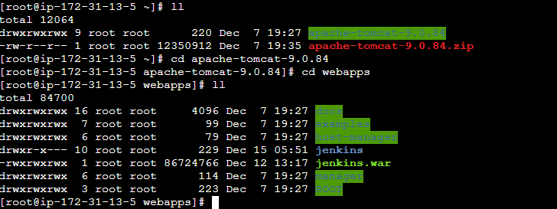

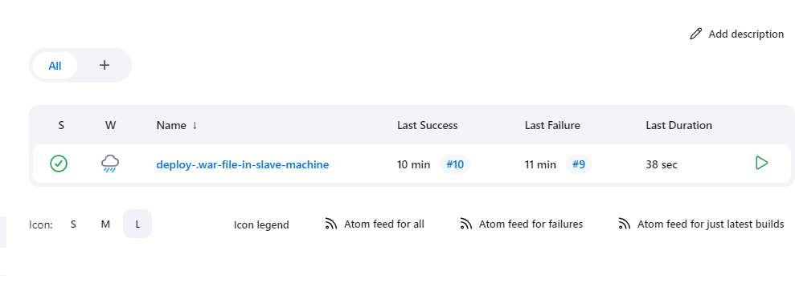

**Step 2:** Launched slave machine (slave-1 and slave-2) and in Jenkins pipeline create slave-1 and slave-2 node.

* On slave machine I install maven ,git, tomcat through Jenkins job

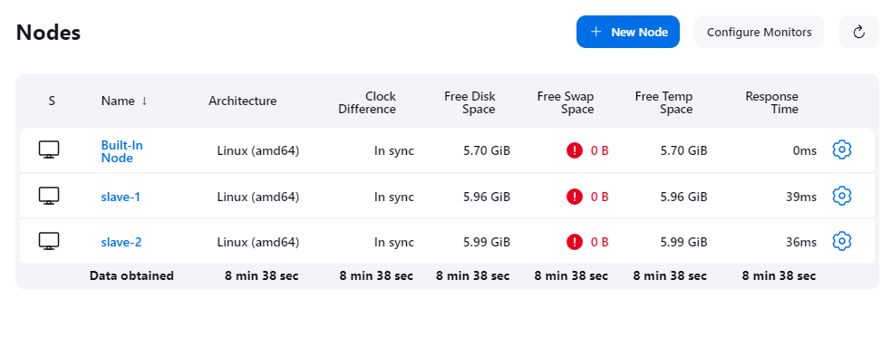

Imp: on both slave machine create Jenkins-slave1 directory.





**Step 3:** Configured Jenkins Master Slave connection using JNLP method:

Note: go on manage jekins 🡪 security 🡪 agent/port no 🡪 and first do random select.

* And when u get port no gain go on security and select fixed and paste port no which u get.

* curl -sO <http://43.205.178.42:8080/jenkins/jnlpJars/agent.jar>
* nohup java -jar agent.jar -jnlpUrl
* http://43.205.178.42:8080/jenkins/computer/slave%2D2/jenkins-agent.jnlp -secret 07fea906afed6aaca3d88a5338c67b6d50b9bc31eb40e4d13908592aaa658cf8 - workDir "/mnt/jenkins-slave" &

when u create nodes , select particular node ,above command u will get and take one by one command and copy and paste to slave machines.

* Nodes are connected to jenkins-master machine

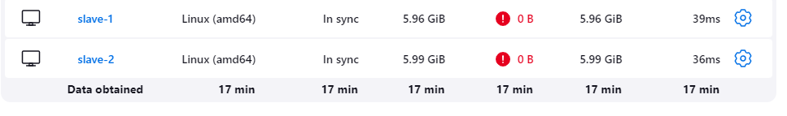

**Step 4:** Created a pipeline job:

Note : set environment variable before job build on slave machines

export MAVEN_HOME=/mnt/build_tools/apache-maven-3.9.6

export PATH=$MAVEN_HOME/bin:$PATH

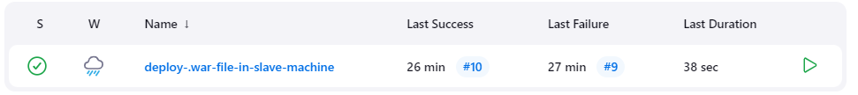

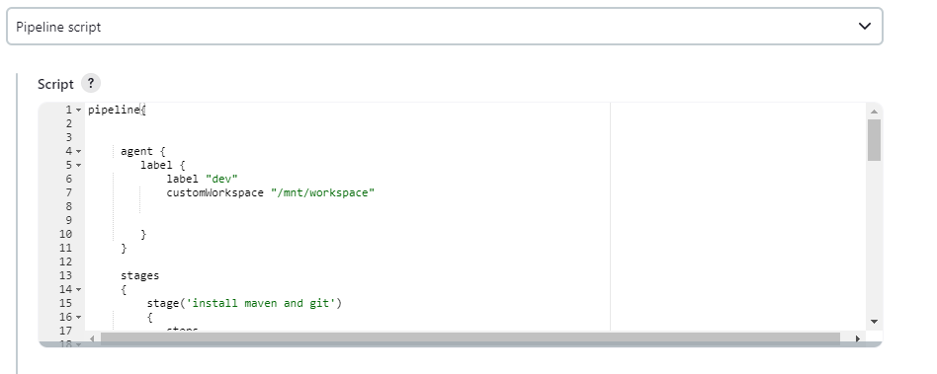

**Script that I’ve created and used for this Pipeline Job**

|  |
| --- |
| pipeline{  agent {  label {  label "dev"  customWorkspace "/mnt/workspace"      }  }    stages  {  stage('install maven and git')  {  steps  {  sh "sudo yum install git -y"  sh "rm -rf *"  dir('/mnt/build-tool')  {  sh "rm -rf apache-maven-3.9.6"  sh "wget https://dlcdn.apache.org/maven/maven-3/3.9.6/binaries/apache-maven-3.9.6-bin.zip"  sh "unzip apache-maven-3.9.6-bin.zip"  sh "rm -rf apache-maven-3.9.6-bin.zip"  sh "sudo chmod -R 777 apache-maven-3.9.6"    }    }  }  stage('git clone')  {  steps  {  git changelog: false, poll: false, url: 'https://github.com/Bamruta/project.git'  }  }    stage('mvn-build')  {  environment  {    PATH = "/mnt/build-tool/apache-maven-3.9.6/bin:$PATH"    }  steps  {  sh "mvn clean install"  }  }    stage('Tomcat')  {  steps  {  sh "mkdir server"  dir("/mnt/server")  {  sh "sudo wget https://dlcdn.apache.org/tomcat/tomcat-9/v9.0.84/bin/apache-tomcat-9.0.84.zip"  sh "sudo unzip apache-tomcat-9.0.84.zip"  sh "sudo rm -rf apache-tomcat-9.0.84.zip"  sh "sudo chmod -R 777 apache-tomcat-9.0.84"  sh "cp /mnt/workspace/target/LoginWebApp.war /mnt/server/apache-tomcat-9.0.84/webapps/"  }  }  }    }  } |
|  |

**Successfully Executed Job**

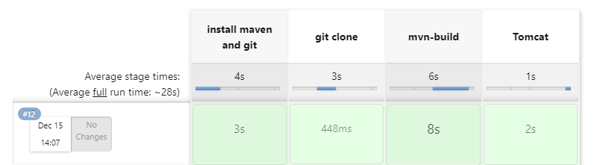

OUTPUT

Note : start tomcat manually

**SLAVE-1**



**SLAVE-2**

